Matrices
Matrix (plural Matrices) is a set of elements or entries arranged in rows and columns forming a rectangular array.
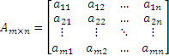
The entries of a matrix will have the suffix ij where i is the row and j is the column to which that value corresponds.

Square matrix
It’s a matrix whose columns are as many as rows, m equals n.
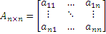

Main diagonal
Also know as (A.k.a.) principal diagonal, primary diagonal, leading diagonal or major diagonal. Is the collection of entries where

Trace
It’s the sum of the elements in the main diagonal.

Column matrix
Column matrix (a.k.a. column vector) is a mx1 matrix.
To represent it lower case Latin letters are commonly used.
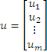

Row matrix
Row matrix (a.k.a. row vector) is a 1xn matrix.
Usually is expressed as the transposed of a column vector.

Transpose
The transpose of a matrix A is another matrix A^{T} (also written A′, A^{tr}, ^{t}A or A^{t}) created by any one of the following equivalent actions:
- Reflect A over its main diagonal (which runs from top-left to bottom-right) to obtain A^{T}
- Write the columns of A as the rows of A^{T}
- Write the rows of A as the columns of A^{T}
Basically the row and column indices change place turning into.
Example:
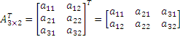

Zero matrix
A zero or null matrix is one with all entries equal to zero, whatever its dimensions might be.

Identity matrix
Also called unit matrix. Is denoted by I_{n} or simply I if size is redundant or irrelevant. It’s a square matrix with ones on the main diagonal and zeros elsewhere.
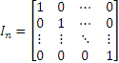
The i-th column of an identity matrix is the unit vector e_{i}.

Conjugate transpose
The conjugate transpose or Hermitian transpose

